**Home Page**

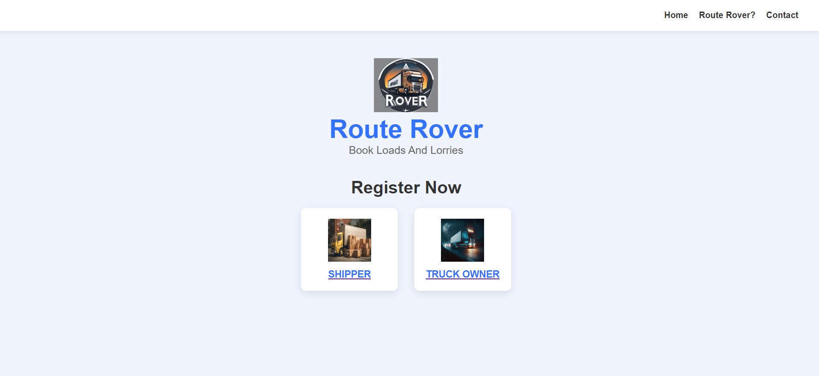





Code: HTML FIle

<!DOCTYPE html>

<html lang="en">

<head>

<title>Route Rover Registration</title>

<link rel="stylesheet" href="home.css">

</head>

<body>

<header>

<nav>

<ul>

<li><a href="#">Home</a></li>

<li><a href="#about-rover">Route Rover?</a></li>

<li><a href="#contact-info">Contact</a></li>

</ul>

</nav>

</header>

<main>

<div class="container">

<div class="logo-section">

<img src="routeroverlogo.jpg" alt="routeroverlogo" class="logo">

<h1>Route Rover</h1>

<p>Book Loads And Lorries</p>

</div>

<div class="register-section">

<h2>Register Now</h2>

<div class="options">

<a href="Shipperregistration.html" class="option">

<img src="shipper.png" alt="shipper">

<p>SHIPPER</p>

</a>

<a href="truck.html" class="option">

<img src="truck.png" alt="Truck owner">

<p>TRUCK OWNER</p>

</a>

</div>

</div>

<!-- Route Rover About Section -->

<div id="about-rover" class="info-section">

<h2>About Route Rover</h2>

<p>A versatile navigation tool for exploring and planning routes, whether for transportation, outdoor activities, or automated systems.</p>

<p>Route Rover helps transport materials from one place to another.</p>

<p>Route Rover is a platform where truck owners and logistics companies can thrive and grow their businesses.</p>

<p>We also provide insurance to truck owners and cargo insurance for safety and security, ensuring a secured future.</p>

<a href="#" class="close-section">Close</a>

</div>

<!-- Contact Info Section -->

<div id="contact-info" class="info-section">

<h2>Contact Us</h2>

<p>Email: support@routerover.com</p>

<p>Phone: +91 12345 67890</p>

<p>Address: Gandhinagar, Gujarat, India</p>

<a href="#" class="close-section">Close</a>

</div>

</div>

</main>

</body>

</html>

**CSS file:**

* {

margin: 0;

padding: 0;

box-sizing: border-box;

font-family: Arial, sans-serif;

}

body {

background-color: #f0f4ff;

color: #333;

}

header {

background-color: #fff;

padding: 20px;

box-shadow: 0 2px 10px rgba(0, 0, 0, 0.1);

}

header nav ul {

list-style-type: none;

display: flex;

justify-content: flex-end;

}

header nav ul li {

margin-right: 20px;

}

header nav ul li a {

text-decoration: none;

color: #333;

font-weight: bold;

}

.container {

max-width: 1200px;

margin: 0 auto;

text-align: center;

padding: 50px 20px;

}

.logo-section {

margin-bottom: 40px;

}

.logo-section img.logo {

width: 120px;

}

.logo-section h1 {

font-size: 48px;

color: #3371ff;

}

.logo-section p {

font-size: 20px;

color: #666;

}

.register-section {

margin-top: 40px;

}

.register-section h2 {

font-size: 32px;

color: #333;

margin-bottom: 20px;

}

.options {

display: flex;

justify-content: center;

gap: 30px;

}

.option {

background-color: #fff;

padding: 20px;

border-radius: 10px;

box-shadow: 0 5px 15px rgba(0, 0, 0, 0.1);

text-align: center;

width: 180px;

transition: transform 0.3s, box-shadow 0.3s;

}

.option:hover {

transform: scale(1.05);

box-shadow: 0 10px 20px rgba(0, 0, 0, 0.2);

}

.option img {

width: 80px;

height: 80px;

margin-bottom: 10px;

}

.option p {

font-size: 18px;

font-weight: bold;

color: #3371ff;

}

/* Info Section Styling */

.info-section {

margin-top: 40px;

background-color: #fff;

padding: 30px;

border-radius: 10px;

box-shadow: 0 5px 15px rgba(0, 0, 0, 0.1);

display: none;

}

.info-section h2 {

font-size: 28px;

margin-bottom: 20px;

}

.info-section p {

font-size: 18px;

color: #333;

}

.close-section {

display: block;

margin-top: 20px;

font-size: 16px;

color: #3371ff;

text-decoration: none;

}

.close-section:hover {

text-decoration: underline;

}

/* Show the targeted section */

:target {

display: block;

}

#about-rover:target, #contact-info:target {

display: block;}

**Registration As Shipper**

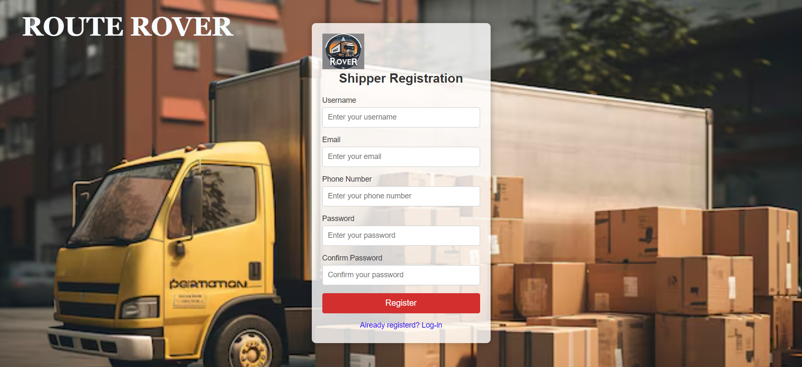

Code: HTML FILE

<!DOCTYPE html>

<html lang="en">

<head>

<title>Shipper Registration - Route Rover</title>

<link rel="stylesheet" href="shipper.css">

</head>

<body>

<div class="container">

<div class="form-box">

<img src="routeroverlogo.jpg" alt="Logo"class="logo" style="align-content: center;">

<h2>Shipper Registration</h2>

<form id="registerForm" onsubmit="return validateForm()">

<!-- Username -->

<div class="input-box">

<label for="username">Username</label>

<input type="text" id="username" name="username" placeholder="Enter your username" required>

<span class="error" id="usernameError"></span>

</div>

<!-- Email -->

<div class="input-box">

<label for="email">Email</label>

<input type="email" id="email" name="email" placeholder="Enter your email" required>

<span class="error" id="emailError"></span>

</div>

<div class="input-box">

<label for="phone">Phone Number</label>

<input type="tel" id="phone" name="phone" placeholder="Enter your phone number" required>

<span class="error" id="loginPhoneError"></span>

</div>

<!-- Password -->

<div class="input-box">

<label for="password">Password</label>

<input type="password" id="password" name="password" placeholder="Enter your password" required>

<span class="error" id="passwordError"></span>

</div>

<!-- Confirm Password -->

<div class="input-box">

<label for="confirmPassword">Confirm Password</label>

<input type="password" id="confirmPassword" name="confirmPassword" placeholder="Confirm your password" required>

<span class="error" id="confirmPasswordError"></span>

</div>

<!-- Submit Button -->

<button type="submit" class="submit-btn">Register</button>

<!-- Forgot Password and Login Links -->

<div class="links">

<a href="loginshipper.html" class="log-in">Already registerd? Log-in</a>

</div>

</form>

</div>

</div>

<script>

function validateForm() {

let username = document.getElementById("username").value;

let email = document.getElementById("email").value;

let password = document.getElementById("password").value;

let confirmPassword = document.getElementById("confirmPassword").value;

let valid = true;

// Clear all error messages

document.getElementById("usernameError").innerHTML = "";

document.getElementById("emailError").innerHTML = "";

document.getElementById("passwordError").innerHTML = "";

document.getElementById("confirmPasswordError").innerHTML = "";

// Username validation (minimum 3 characters)

if (username.length < 3) {

document.getElementById("usernameError").innerHTML = "Username must be at least 3 characters.";

valid = false;

}

// Email validation (simple pattern)

let emailPattern = /^[a-zA-Z0-9._-]+@[a-zA-Z0-9.-]+\.[a-zA-Z]{2,6}$/;

if (!emailPattern.test(email)) {

document.getElementById("emailError").innerHTML = "Invalid email address.";

valid = false;

}

// Phone number validation (basic check)

let phonePattern = /^[0-9]{10}$/; // Basic 10-digit validation

if (!phonePattern.test(phone)) {

document.getElementById("loginPhoneError").innerHTML = "Phone number must be 10 digits.";

valid = false;

}

// Password validation (minimum 6 characters)

if (password.length < 6) {

document.getElementById("passwordError").innerHTML = "Password must be at least 6 characters.";

valid = false;

}

// Confirm password validation (must match password)

if (password !== confirmPassword) {

document.getElementById("confirmPasswordError").innerHTML = "Passwords do not match.";

valid = false;

}

return valid; // return false if validation fails

}

</script>

</body>

</html>

**LOgin As Shipper:**

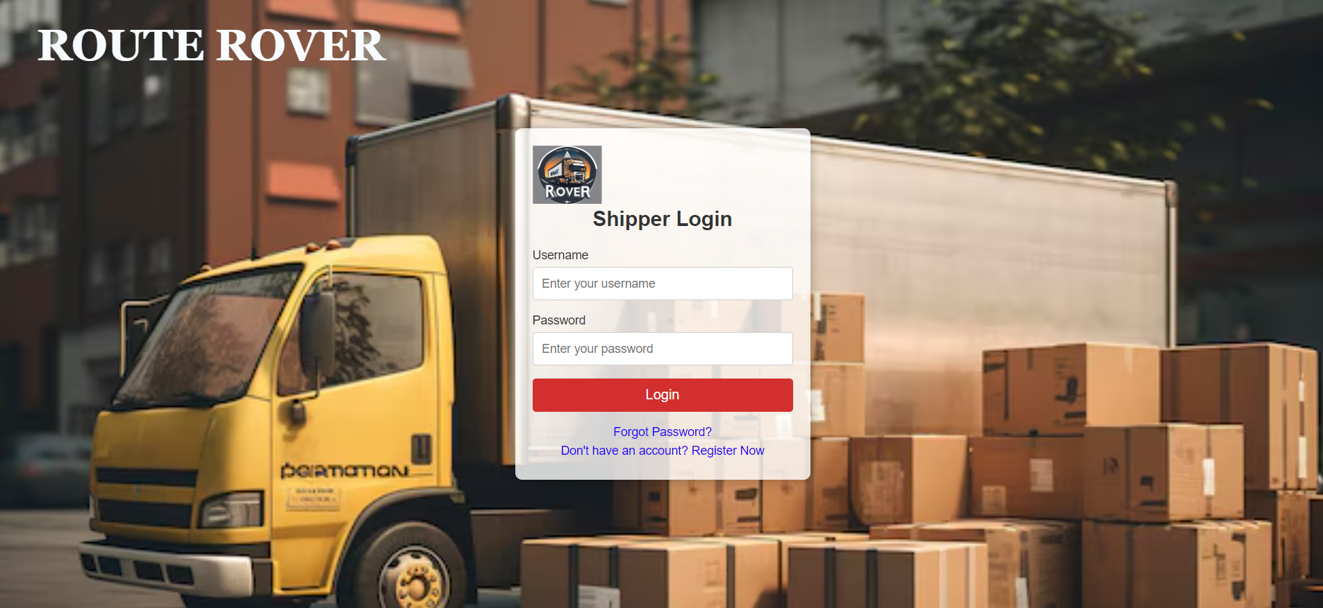

CODE:HTML FILE

<!DOCTYPE html>

<html lang="en">

<head>

<title>Shipper Login - Route Rover</title>

<link rel="stylesheet" href="shipper.css">

</head>

<body>

<div class="container">

<div class="form-box">

<img src="routeroverlogo.jpg" alt="Logo"class="logo">

<h2>Shipper Login</h2>

<form id="loginForm" onsubmit="return validateLoginForm()">

<!-- Username -->

<div class="input-box">

<label for="username">Username</label>

<input type="text" id="username" name="username" placeholder="Enter your username" required>

<span class="error" id="loginUsernameError"></span>

</div>

<!-- Password -->

<div class="input-box">

<label for="password">Password</label>

<input type="password" id="password" name="password" placeholder="Enter your password" required>

<span class="error" id="loginPasswordError"></span>

</div>

<!-- Submit Button -->

<button type="submit" class="submit-btn">Login</button>

<!-- Forgot Password and Register Links -->

<div class="links">

<a href="#" class="forgot-password">Forgot Password?</a>

<a href="truckregistration.html" class="register-now">Don't have an account? Register Now</a>

</div>

</form>

</div>

</div>

<script>

function validateLoginForm() {

let username = document.getElementById("username").value;

let password = document.getElementById("password").value;

let valid = true;

// Clear all error messages

document.getElementById("loginUsernameError").innerHTML = "";

document.getElementById("loginPasswordError").innerHTML = "";

// Username validation (minimum 3 characters)

if (username.length < 3) {

document.getElementById("loginUsernameError").innerHTML = "Username must be at least 3 characters.";

valid = false;

}

// Password validation (minimum 6 characters)

if (password.length < 6) {

document.getElementById("loginPasswordError").innerHTML = "Password must be at least 6 characters.";

valid = false;

}

return valid; // return false if validation fails

}

</script>

</body>

</html>

**CSS FILE of regtration and login of Shipper:**

* {

margin: 0;

padding: 0;

box-sizing: border-box;

font-family: 'Arial', sans-serif;

}

body {

background-image: url('shipper.png');

background-size: cover;

display: flex;

justify-content: center;

align-items: center;

align-content:center ;

height: 100vh;

}

body::before {

content: "ROUTE ROVER";

position:absolute;

top: 10%;

left: 50%;

transform: translate(-180%, -80%);

font-size: 50px; /* Adjust size as needed */

font-family:Georgia, 'Times New Roman', Times, serif;

color: rgb(248, 252, 255);

font-weight: bold;

z-index: 0; /* Ensures it's behind the form */

pointer-events: none; /* Allows clicks through the background text */

}

.container {

position: absolute; /* Ensure it stacks over the background text */

background-color: rgba(255, 255, 255, 0.8);

padding: 20px;

border-radius: 8px;

box-shadow: 0 0 15px rgba(0, 0, 0, 0.3);

z-index: 1; /* Ensures form is above the background text */

}

.container {

background-color: rgba(255, 255, 255, 0.8);

padding: 20px;

border-radius: 8px;

box-shadow: 0 0 15px rgba(0, 0, 0, 0.3);

}

.form-box {

width: 300px;

}

.logo-container {

display: flex;

justify-content: center;

align-items: center;

margin-bottom: 20px;

}

.logo {

max-width: 80px;

height: auto;

}

h2 {

text-align: center;

margin-bottom: 20px;

color: #333;

}

.input-box {

margin-bottom: 15px;

}

.input-box label {

display: block;

margin-bottom: 5px;

font-size: 14px;

color: #333;

}

.input-box input {

width: 100%;

padding: 10px;

border: 1px solid #ccc;

border-radius: 4px;

font-size: 14px;

}

.submit-btn {

width: 100%;

padding: 10px;

background-color: #d32f2f;

color: #fff;

border: none;

border-radius: 4px;

cursor: pointer;

font-size: 16px;

}

.submit-btn:hover {

background-color: #c62828;

}

.error {

color: red;

font-size: 12px;

}

.links {

text-align: center;

margin-top: 15px;

}

.links a {

display: block;

margin: 5px 0;

text-decoration: none;

color: #2805ef;

font-size: 14px;

}

.links a:hover {

color: #4828c6;

text-decoration: underline;

}

**REGISTRATION AS TRUCK OWNER**

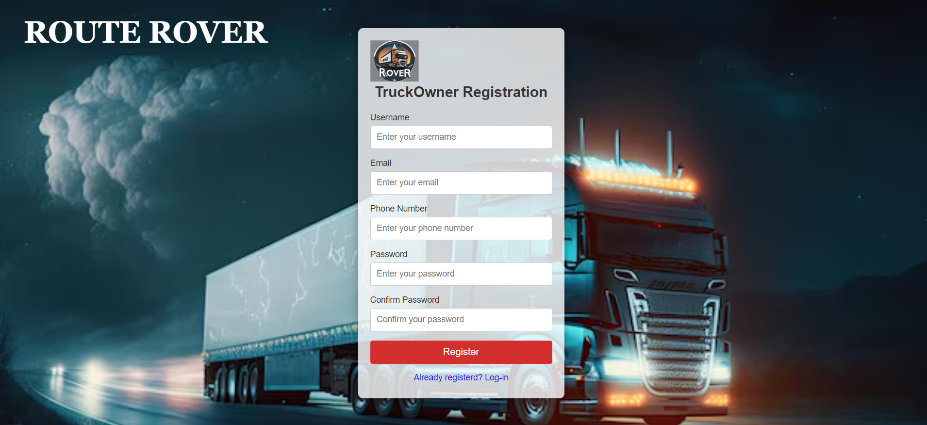

CODE:

<!DOCTYPE html>

<html lang="en">

<head>

<title>TruckOwner Registration - Route Rover</title>

<link rel="stylesheet" href="truck.css">

</head>

<body>

<div class="container">

<div class="form-box">

<img src="routeroverlogo.jpg" alt="Logo"class="logo" style="align-content: center;">

<h2>TruckOwner Registration</h2>

<form id="registerForm" onsubmit="return validateForm()">

<!-- Username -->

<div class="input-box">

<label for="username">Username</label>

<input type="text" id="username" name="username" placeholder="Enter your username" required>

<span class="error" id="usernameError"></span>

</div>

<!-- Email -->

<div class="input-box">

<label for="email">Email</label>

<input type="email" id="email" name="email" placeholder="Enter your email" required>

<span class="error" id="emailError"></span>

</div>

<div class="input-box">

<label for="phone">Phone Number</label>

<input type="tel" id="phone" name="phone" placeholder="Enter your phone number" required>

<span class="error" id="loginPhoneError"></span>

</div>

<!-- Password -->

<div class="input-box">

<label for="password">Password</label>

<input type="password" id="password" name="password" placeholder="Enter your password" required>

<span class="error" id="passwordError"></span>

</div>

<!-- Confirm Password -->

<div class="input-box">

<label for="confirmPassword">Confirm Password</label>

<input type="password" id="confirmPassword" name="confirmPassword" placeholder="Confirm your password" required>

<span class="error" id="confirmPasswordError"></span>

</div>

<!-- Submit Button -->

<button type="submit" class="submit-btn">Register</button>

<!-- Forgot Password and Login Links -->

<div class="links">

<a href="logintruck.html" class="log-in">Already registerd? Log-in</a>

</div>

</form>

</div>

</div>

<script>

function validateForm() {

let username = document.getElementById("username").value;

let email = document.getElementById("email").value;

let password = document.getElementById("password").value;

let confirmPassword = document.getElementById("confirmPassword").value;

let valid = true;

// Clear all error messages

document.getElementById("usernameError").innerHTML = "";

document.getElementById("emailError").innerHTML = "";

document.getElementById("passwordError").innerHTML = "";

document.getElementById("confirmPasswordError").innerHTML = "";

// Username validation (minimum 3 characters)

if (username.length < 3) {

document.getElementById("usernameError").innerHTML = "Username must be at least 3 characters.";

valid = false;

}

// Email validation (simple pattern)

let emailPattern = /^[a-zA-Z0-9._-]+@[a-zA-Z0-9.-]+\.[a-zA-Z]{2,6}$/;

if (!emailPattern.test(email)) {

document.getElementById("emailError").innerHTML = "Invalid email address.";

valid = false;

}

// Phone number validation (basic check)

let phonePattern = /^[0-9]{10}$/; // Basic 10-digit validation

if (!phonePattern.test(phone)) {

document.getElementById("loginPhoneError").innerHTML = "Phone number must be 10 digits.";

valid = false;

}

// Password validation (minimum 6 characters)

if (password.length < 6) {

document.getElementById("passwordError").innerHTML = "Password must be at least 6 characters.";

valid = false;

}

// Confirm password validation (must match password)

if (password !== confirmPassword) {

document.getElementById("confirmPasswordError").innerHTML = "Passwords do not match.";

valid = false;

}

return valid; // return false if validation fails

}

</script>

</body>

</html>

**LOG IN AS TRUCKOWNER:**

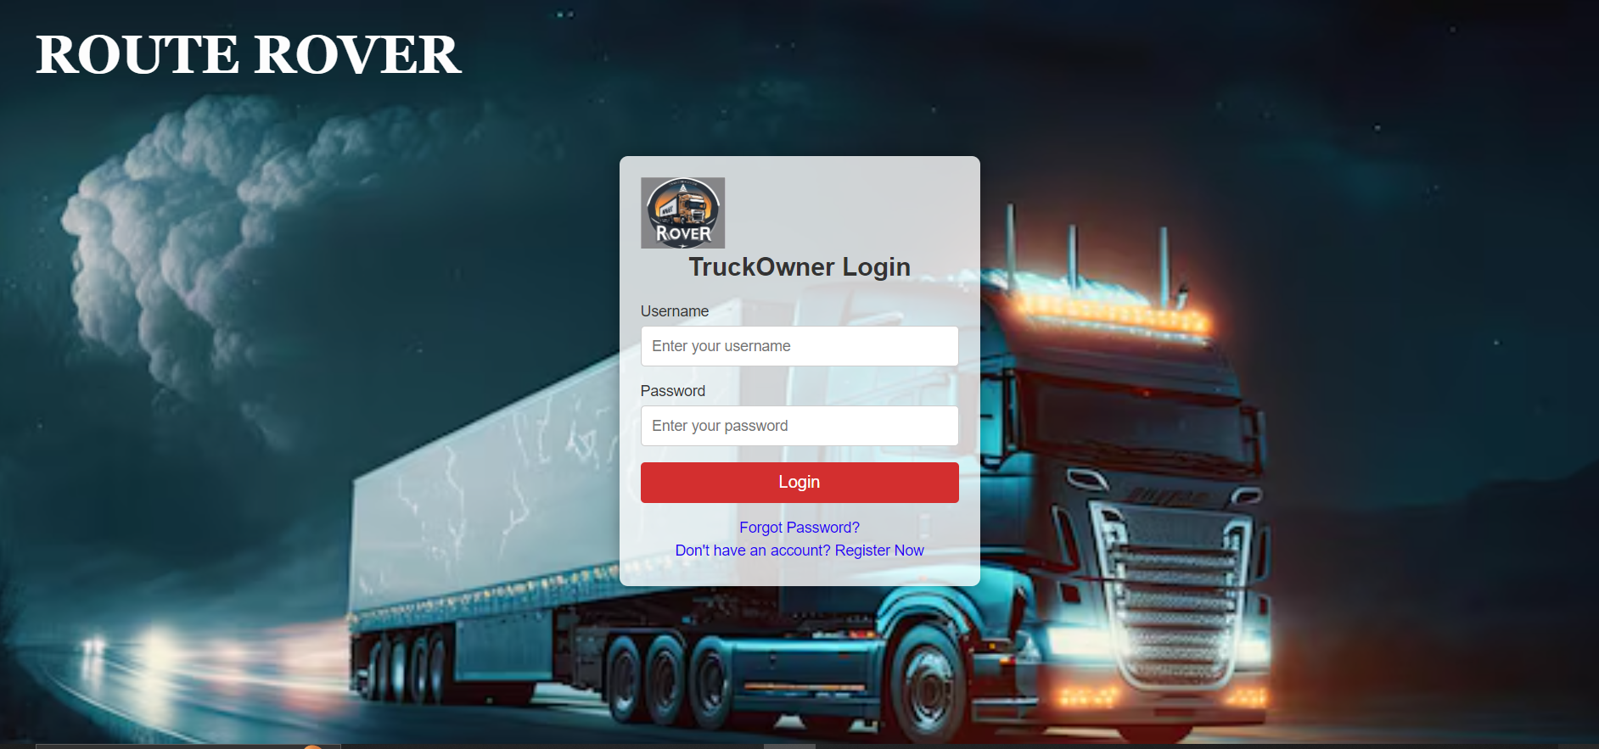

CODE:

<!DOCTYPE html>

<html lang="en">

<head>

<title>TruckOwner Login - Route Rover</title>

<link rel="stylesheet" href="truck.css">

</head>

<body>

<div class="container">

<div class="form-box">

<img src="routeroverlogo.jpg" alt="Logo"class="logo">

<h2>TruckOwner Login</h2>

<form id="loginForm" onsubmit="return validateLoginForm()">

<!-- Username -->

<div class="input-box">

<label for="username">Username</label>

<input type="text" id="username" name="username" placeholder="Enter your username" required>

<span class="error" id="loginUsernameError"></span>

</div>

<!-- Password -->

<div class="input-box">

<label for="password">Password</label>

<input type="password" id="password" name="password" placeholder="Enter your password" required>

<span class="error" id="loginPasswordError"></span>

</div>

<!-- Submit Button -->

<button type="submit" class="submit-btn">Login</button>

<!-- Forgot Password and Register Links -->

<div class="links">

<a href="#" class="forgot-password">Forgot Password?</a>

<a href="truck.html" class="register-now">Don't have an account? Register Now</a>

</div>

</form>

</div>

</div>

<script>

function validateLoginForm() {

let username = document.getElementById("username").value;

let password = document.getElementById("password").value;

let valid = true;

// Clear all error messages

document.getElementById("loginUsernameError").innerHTML = "";

document.getElementById("loginPasswordError").innerHTML = "";

// Username validation (minimum 3 characters)

if (username.length < 3) {

document.getElementById("loginUsernameError").innerHTML = "Username must be at least 3 characters.";

valid = false;

}

// Password validation (minimum 6 characters)

if (password.length < 6) {

document.getElementById("loginPasswordError").innerHTML = "Password must be at least 6 characters.";

valid = false;

}

return valid; // return false if validation fails

}

</script>

</body>

</html>

**CSS FILE OF REGISTRATION AND LOGIN OF TRUCK OWNER**:

* {

margin: 0;

padding: 0;

box-sizing: border-box;

font-family: 'Arial', sans-serif;

}

body {

background-image: url('truck.png');

background-size: cover;

display: flex;

justify-content: center;

align-items: center;

align-content:center ;

height: 100vh;

}

body::before {

content: "ROUTE ROVER";

position:absolute;

top: 10%;

left: 50%;

transform: translate(-180%, -80%);

font-size: 50px; /* Adjust size as needed */

font-family:Georgia, 'Times New Roman', Times, serif;

color: rgb(253, 253, 253);

font-weight: bold;

z-index: 0; /* Ensures it's behind the form */

pointer-events: none; /* Allows clicks through the background text */

}

.container {

position: absolute; /* Ensure it stacks over the background text */

background-color: rgba(255, 255, 255, 0.8);

padding: 20px;

border-radius: 8px;

box-shadow: 0 0 15px rgba(0, 0, 0, 0.3);

z-index: 1; /* Ensures form is above the background text */

}

.container {

background-color: rgba(255, 255, 255, 0.8);

padding: 20px;

border-radius: 8px;

box-shadow: 0 0 15px rgba(0, 0, 0, 0.3);

}

.form-box {

width: 300px;

}

.logo-container {

display: flex;

justify-content: center;

align-items: center;

margin-bottom: 20px;

}

.logo {

max-width: 80px;

height: auto;

}

h2 {

text-align: center;

margin-bottom: 20px;

color: #333;

}

.input-box {

margin-bottom: 15px;

}

.input-box label {

display: block;

margin-bottom: 5px;

font-size: 14px;

color: #333;

}

.input-box input {

width: 100%;

padding: 10px;

border: 1px solid #ccc;

border-radius: 4px;

font-size: 14px;

}

.submit-btn {

width: 100%;

padding: 10px;

background-color: #d32f2f;

color: #fff;

border: none;

border-radius: 4px;

cursor: pointer;

font-size: 16px;

}

.submit-btn:hover {

background-color: #c62828;

}

.error {

color: red;

font-size: 12px;

}

.links {

text-align: center;

margin-top: 15px;

}

.links a {

display: block;

margin: 5px 0;

text-decoration: none;

color: #2805ef;

font-size: 14px;

}

.links a:hover {

color: #4828c6;

text-decoration: underline;

}

**REGISTRATION OF ADMIN**

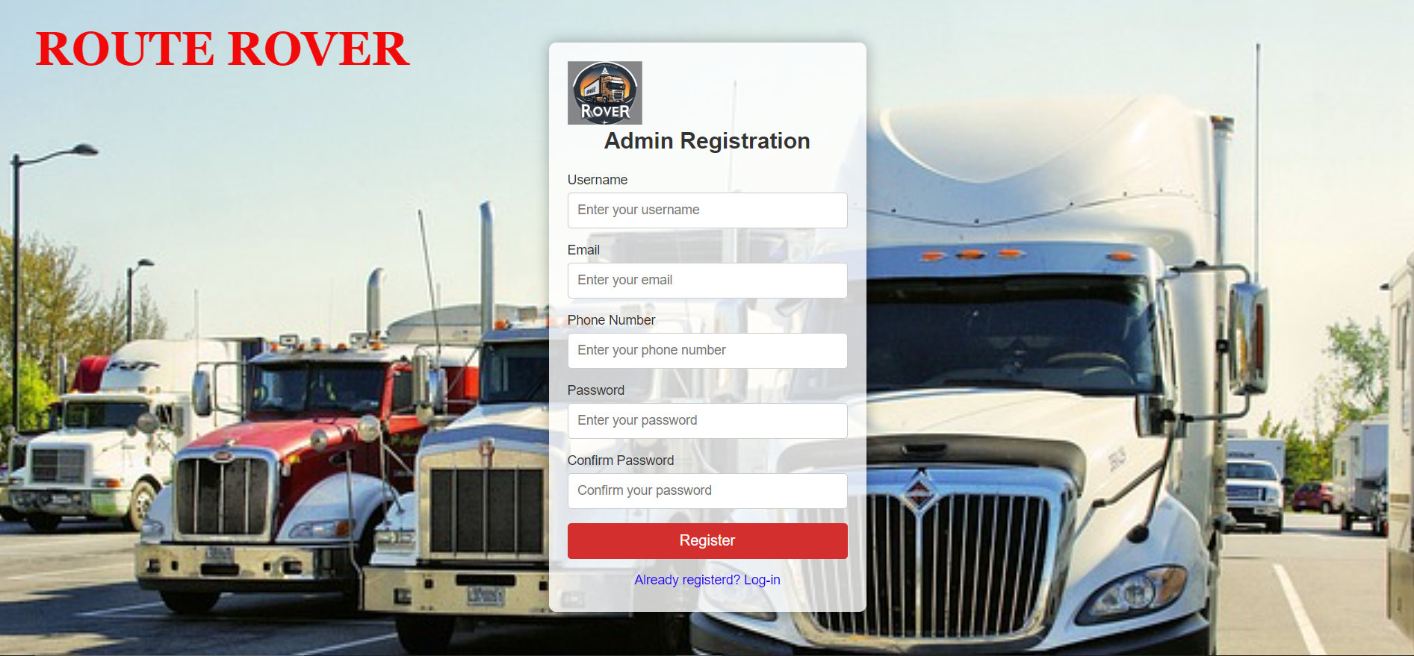

CODE

<!DOCTYPE html>

<html lang="en">

<head>

<title>Admin Registration - Route Rover</title>

<link rel="stylesheet" href="adminregistration.css">

</head>

<body>

<div class="container">

<div class="form-box">

<img src="routeroverlogo.jpg" alt="Logo"class="logo" style="align-content: center;">

<h2>Admin Registration</h2>

<form id="registerForm" onsubmit="return validateForm()">

<!-- Username -->

<div class="input-box">

<label for="username">Username</label>

<input type="text" id="username" name="username" placeholder="Enter your username" required>

<span class="error" id="usernameError"></span>

</div>

<!-- Email -->

<div class="input-box">

<label for="email">Email</label>

<input type="email" id="email" name="email" placeholder="Enter your email" required>

<span class="error" id="emailError"></span>

</div>

<div class="input-box">

<label for="phone">Phone Number</label>

<input type="tel" id="phone" name="phone" placeholder="Enter your phone number" required>

<span class="error" id="loginPhoneError"></span>

</div>

<!-- Password -->

<div class="input-box">

<label for="password">Password</label>

<input type="password" id="password" name="password" placeholder="Enter your password" required>

<span class="error" id="passwordError"></span>

</div>

<!-- Confirm Password -->

<div class="input-box">

<label for="confirmPassword">Confirm Password</label>

<input type="password" id="confirmPassword" name="confirmPassword" placeholder="Confirm your password" required>

<span class="error" id="confirmPasswordError"></span>

</div>

<!-- Submit Button -->

<button type="submit" class="submit-btn">Register</button>

<!-- Forgot Password and Login Links -->

<div class="links">

<a href="login admin.html" class="log-in">Already registerd? Log-in</a>

</div>

</form>

</div>

</div>

<script>

function validateForm() {

let username = document.getElementById("username").value;

let email = document.getElementById("email").value;

let password = document.getElementById("password").value;

let confirmPassword = document.getElementById("confirmPassword").value;

let valid = true;

// Clear all error messages

document.getElementById("usernameError").innerHTML = "";

document.getElementById("emailError").innerHTML = "";

document.getElementById("passwordError").innerHTML = "";

document.getElementById("confirmPasswordError").innerHTML = "";

// Username validation (minimum 3 characters)

if (username.length < 3) {

document.getElementById("usernameError").innerHTML = "Username must be at least 3 characters.";

valid = false;

}

// Email validation (simple pattern)

let emailPattern = /^[a-zA-Z0-9._-]+@[a-zA-Z0-9.-]+\.[a-zA-Z]{2,6}$/;

if (!emailPattern.test(email)) {

document.getElementById("emailError").innerHTML = "Invalid email address.";

valid = false;

}

// Phone number validation (basic check)

let phonePattern = /^[0-9]{10}$/; // Basic 10-digit validation

if (!phonePattern.test(phone)) {

document.getElementById("loginPhoneError").innerHTML = "Phone number must be 10 digits.";

valid = false;

}

// Password validation (minimum 6 characters)

if (password.length < 6) {

document.getElementById("passwordError").innerHTML = "Password must be at least 6 characters.";

valid = false;

}

// Confirm password validation (must match password)

if (password !== confirmPassword) {

document.getElementById("confirmPasswordError").innerHTML = "Passwords do not match.";

valid = false;

}

return valid; // return false if validation fails

}

</script>

</body>

</html>

**LOG IN AS ADMIN:**

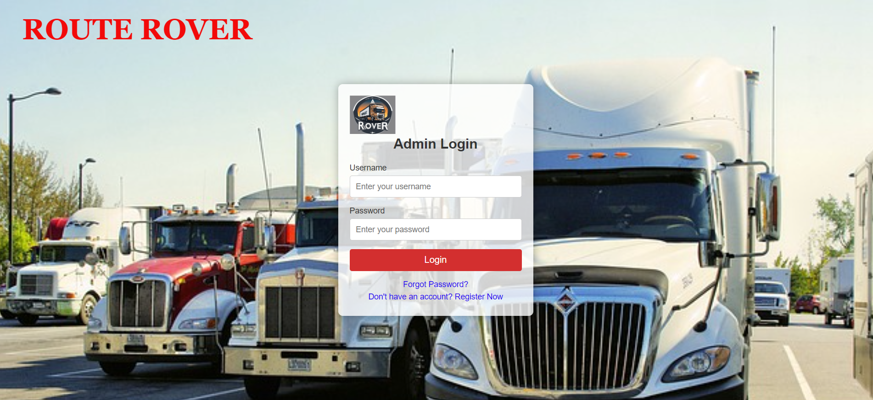

CODE:

<!DOCTYPE html>

<html lang="en">

<head>

<title>Admin Login - Route Rover</title>

<link rel="stylesheet" href="adminregistration.css">

</head>

<body>

<div class="container">

<div class="form-box">

<img src="routeroverlogo.jpg" alt="Logo"class="logo">

<h2>Admin Login</h2>

<form id="loginForm" onsubmit="return validateLoginForm()">

<!-- Username -->

<div class="input-box">

<label for="username">Username</label>

<input type="text" id="username" name="username" placeholder="Enter your username" required>

<span class="error" id="loginUsernameError"></span>

</div>

<!-- Password -->

<div class="input-box">

<label for="password">Password</label>

<input type="password" id="password" name="password" placeholder="Enter your password" required>

<span class="error" id="loginPasswordError"></span>

</div>

<!-- Submit Button -->

<button type="submit" class="submit-btn">Login</button>

<!-- Forgot Password and Register Links -->

<div class="links">

<a href="#" class="forgot-password">Forgot Password?</a>

<a href="Shipperregistration.html" class="register-now">Don't have an account? Register Now</a>

</div>

</form>

</div>

</div>

<script>

function validateLoginForm() {

let username = document.getElementById("username").value;

let password = document.getElementById("password").value;

let valid = true;

// Clear all error messages

document.getElementById("loginUsernameError").innerHTML = "";

document.getElementById("loginPasswordError").innerHTML = "";

// Username validation (minimum 3 characters)

if (username.length < 3) {

document.getElementById("loginUsernameError").innerHTML = "Username must be at least 3 characters.";

valid = false;

}

// Password validation (minimum 6 characters)

if (password.length < 6) {

document.getElementById("loginPasswordError").innerHTML = "Password must be at least 6 characters.";

valid = false;

}

return valid; // return false if validation fails

}

</script>

</body>

</html>

**CSS FILE OF REGISTRATION AND LOGIN OF ADMIN**

* {

margin: 0;

padding: 0;

box-sizing: border-box;

font-family: 'Arial', sans-serif;

}

body {

background-image: url('admin.png');

background-size: cover;

display: flex;

justify-content: center;

align-items: center;

align-content:center ;

height: 100vh;

}

body::before {

content: "ROUTE ROVER";

position:absolute;

top: 10%;

left: 50%;

transform: translate(-180%, -80%);

font-size: 50px; /* Adjust size as needed */

font-family:Georgia, 'Times New Roman', Times, serif;

color: #fcfdff;

font-weight: bold;

z-index: 0; /* Ensures it's behind the form */

pointer-events: none; /* Allows clicks through the background text */

}

.container {

position: absolute; /* Ensure it stacks over the background text */

background-color: rgba(255, 255, 255, 0.8);

padding: 20px;

border-radius: 8px;

box-shadow: 0 0 15px rgba(0, 0, 0, 0.3);

z-index: 1; /* Ensures form is above the background text */

}

.container {

background-color: rgba(255, 255, 255, 0.8);

padding: 20px;

border-radius: 8px;

box-shadow: 0 0 15px rgba(0, 0, 0, 0.3);

}

.form-box {

width: 300px;

}

.logo-container {

display: flex;

justify-content: center;

align-items: center;

margin-bottom: 20px;

}

.logo {

max-width: 80px;

height: auto;

}

h2 {

text-align: center;

margin-bottom: 20px;

color: #333;

}

.input-box {

margin-bottom: 15px;

}

.input-box label {

display: block;

margin-bottom: 5px;

font-size: 14px;

color: #333;

}

.input-box input {

width: 100%;

padding: 10px;

border: 1px solid #ccc;

border-radius: 4px;

font-size: 14px;

}

.submit-btn {

width: 100%;

padding: 10px;

background-color: #d32f2f;

color: #fff;

border: none;

border-radius: 4px;

cursor: pointer;

font-size: 16px;

}

.submit-btn:hover {

background-color: #c62828;

}

.error {

color: red;

font-size: 12px;

}

.links {

text-align: center;

margin-top: 15px;

}

.links a {

display: block;

margin: 5px 0;

text-decoration: none;

color: #2805ef;

font-size: 14px;

}

.links a:hover {

color: #4828c6;

text-decoration: underline;

}